Visiting and Working in Malawi

Induction Pack for Volunteers

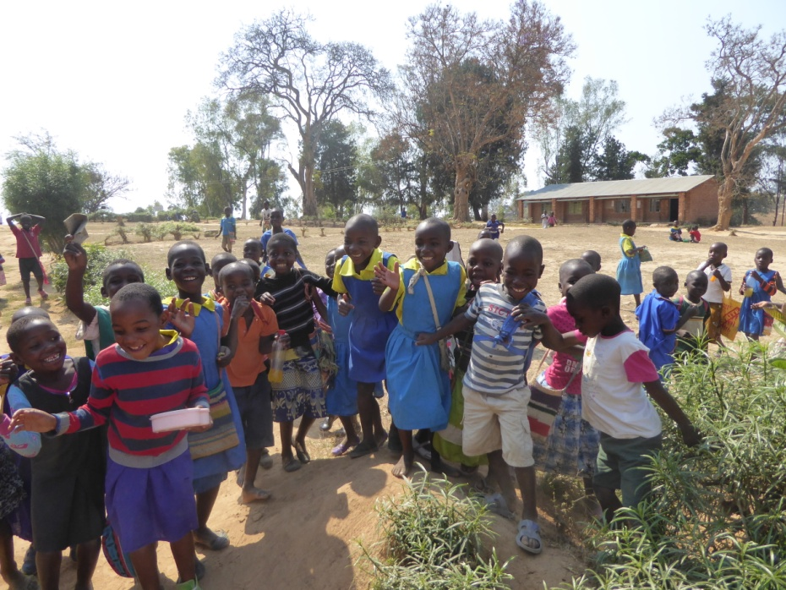

Introduction
Having now volunteered for taking part in one of Smileawi’s dental care aid trips to Malawi, you will presumably have some understanding of the work undertaken by the charity and at least a little knowledge of the country itself.
If you still have gaps in your understanding, the easiest way to gain more information about the organisation’s origins and development, the type of work we do and fundraising activities run by Smileawi supporters, is to visit:- The website at www.smileawi.com The Facebook entries at https://en-gb.facebook.com/Smileawi2012/
You will presumably by now have gained information at one of our information evenings, or through the available information leaflet. This induction pack however aims to provide further practical information for your trip as a fully signed up and committed volunteer.
Firstly, we have to tell you that your trip will undoubtedly be one the best adventures of your life and will provide you with amazing memories for the rest of your days. How can we make such a bold boast? – because that’s what everyone who has volunteered in the past has told us!
It is inevitable that you might have questions about the trip and we will try to help you in the following pages in a sort of Q & A format. We appreciate however that you cannot get a complete idea of what lies ahead simply from written word. You will need to go on the trip to get this....... and that’s the fun! We can describe the sights, sounds and smells of Malawi, the people, the joy of working in a close-knit team providing dental care which would otherwise be inaccessible....but words can’t do justice to experiencing the real thing.
Undoubtedly there are pros and cons during a trip and this induction pack should hopefully allow you to prepare yourself so that the cons are minimised. Oddly, even most of the downsides enhance the experience and will become treasured memories too.
The following pages have been divided up under the following headings. We go as a team and most of the topics apply to all volunteers but, where appropriate, we have provided different sections for different roles ( eg for dentists and dental nurses.)
- A little about Malawi
- Am I a suitable volunteer?
- Preparing for the trip – a timeline
- General FAQs

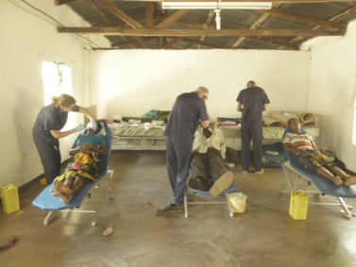

A little about Malawi
Malawi is one of SE Africa’s smallest countries and is bordered by three much larger neighbours, Zambia, Tanzania and Mozambique. Probably its greatest physical feature is Lake Malawi (or Nyasa) which, at 360 miles long and 47 miles wide, runs approximately two- thirds the length of the country. Although Malawi is located in sub-Saharan Africa, the temperatures are often not oppressive as much of the country lies at an altitude and this tempers the heat.
Malawi’s strengths can also be its weaknesses. It is, for an African country, very peaceable with a relatively stable political situation. (It has never had a war since gaining independence in 1964.) It has therefore not suffered the upheaval that many of the surrounding countries have endured, but therein arguably lies its weakness. As a docile country with a heavy reliance on external aid, the Malawian economy has never really flourished and this has resulted in its unenviable position as one of the very poorest countries in the world. Statistics for average lifespan, levels of unemployment, poverty, healthcare and infrastructure are frightening.
It is however a stunningly beautiful country and, even today, the link with Scotland survives primarily due to the two countries connection by our nation’s greatest African explorer, David Livingstone, and the other Scots who followed in his footsteps.
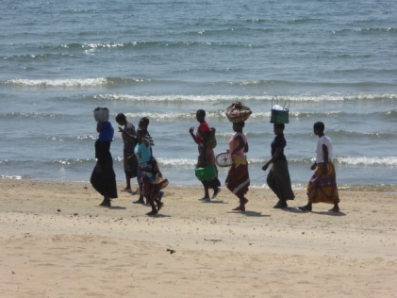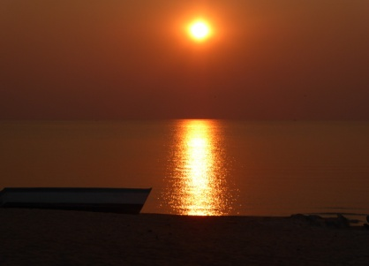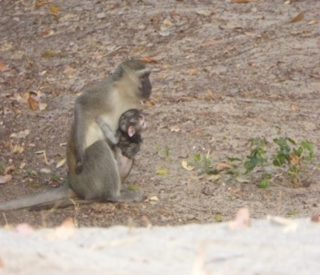
If you’re keen to learn more about Malawi, you can do worse than looking it up on Wikipedia or reading some of the numerous books which could give a different slant to your understanding of the country. (We have included a short list of some books in the FAQs later in the pack.)
Visiting Malawi is an adventure in itself, particularly if you have not previously visited sub-Saharan Africa. Working alongside Malawians provides an additional element to your experience as you automatically learn about local customs and lifestyles, and make friends at the same time. Additionally, by being part of the Smileawi team, you will have the opportunity to see remote parts of the country which even the occasional tourist to the country is unlikely to visit. In general, more of the country’s development over the last hundred years or so has taken place in the south of the country. Smileawi’s trips have focussed on the northern regions, often being based in regions which are considered some of the poorest areas of the country. As a result, as a volunteer, you will be working in relatively poorly developed areas, helping people who otherwise would not have the opportunity to access dental care at all. As you can imagine, this means the workload is furious.....but the recipients of your efforts are grateful to a level way beyond anything you experience in your normal jobs at home.

Am I a suitable volunteer?
Below are some practicalities around volunteering:-
- Timing.
The trips, which have to be arranged well in advance, are only available at fixed dates. You should therefore ensure that, barring unforeseen issues, you are able to travel on the agreed dates and have made firm arrangements to have the time off work. Unfortunately, there is no flexibility around this.

- Funding.
Although Smileawi constantly fundraises, the money raised from this goes to support the various expenses incurred by the charity, such as purchase of materials and instruments. All volunteers must therefore self-fund their own trip in addition to devoting their time. Of course, you may choose to raise funds independently to pay for the trip and hopefully we can help you achieve this by working very hard to ensure that volunteer costs are kept to a minimum. Unfortunately however we do need to be strict about funding in order to ensure that we provide maximum support to those in need and this means that we have to ensure payment of travel etc by a specific date which is usually at least a couple of months before the trip.

- Health
Working in Malawi can be taxing; the hours are long and the workload is heavy. For this reason, volunteering is not something you should consider if you are currently suffering ill-health. Additionally, once in Malawi, available medical care can be very rudimentary so travelling with ongoing problems is not advisable. Specifically, that age-old dentists’ problem of backache can be challenging as seated dentistry is not an option with the Dentaid portable dental chairs, and this is not always helpful should backache arise. Hygiene in Malawi is challenging and working there is not without its health risks. (Thankfully no volunteer has yet succumbed to any serious problems.) You should however be aware of obvious risks such as HIV, hepatitis, malaria, tetanus etc and ensure that you are fully covered by immunisation and preventative medication where appropriate. A table of necessary pre-travel inoculations and precautions has been inserted later in the induction pack.

- Qualifications & experience (dentists and support staff noted separately)

Dentists :- 90+% of the treatment provided by Smileawi is dental extractions. The need for pain relief is so great and the availability of water and electricity so limited, that this is almost always the only practical treatment which can be offered. So an ability to remove teeth is a must.
The level of extraction difficulty varies enormously and while some are easy or straightforward, there is no doubt that some are extremely challenging. Add to this the fact that there is no surgical extraction fall-back (due to no water supply and no electricity for suction or drills), combined with probable poor lighting, it will be apparent that some extractions are ‘stinkers’. The use of elevators and luxators is necessary in many cases and familiarity with using these instruments will be a near-necessity.
However one of the great things for all of us is being part of a team so you will always have someone to call on if you are struggling with a difficult case.
On busy clinics the number of patients can seem overwhelming but it is amazing what through-put can be achieved in a day. There is no doubt that you will be a bit of an extraction expert at the end of your stint!

Dental nurses / support staff :- The main task of support staff is one of instrument sterilisation. There are no autoclaves and instruments are sterilised in pressure cookers powered by calor gas rings......and the number of instruments needing recycled, (sterilised, sorted, bagged and stored) can be BIG. The processes can be easily learnt in a relatively short space of time, even for someone not currently familiar with modern cross infection control protocols. The work can however be taxing due to the heat and while it probably can’t be described as glamourous, it’s absolutely pivotal to the success of the mission. Indeed, without this support, the help provided to the patients wouldn’t even get off the ground, so all volunteers should never doubt the immense value of their contribution.

For both roles, there is no real limit to participation based on experience - there are benefits of both youth and experience in a team, and it’s this sense of teamwork that contributes to the great feel-good factor which has been felt by all our past volunteers.

- Adaptability
Malawi isn’t Scotland (!), so things like accommodation, food and travelling around are different. If you have a more adventurous spirit, this all adds to the experience, but if you are someone who values luxuries dearly, you should expect to find things a bit more challenging. That’s not to say that conditions are harsh. Accommodation can be simple but comfortable, there is enough food and vehicles are good by Malawi standards. Getting to outlying clinics can involve early rises and fairly long car journeys but visiting rural and remote villages can be thrilling. You should also be aware of other situations which are different – for example, a “Malawi shower” can be an interesting way of bathing; and unfamiliar and interesting bugs may not be overly welcomed if you are a bit squeamish about this sort of thing. Malawians are very friendly and grateful for help, but language, customs and things like levels of cleanliness are different. Local interpreters and health care workers give the team loads of help when it comes to welcoming patients, seeking the answer to diagnostic questions and setting up clinics, so not being able to speak the local lingo is not a problem.

Preparing for the trip – a timeline
WHEN  Time before trip | REQUIREMENT  What needs to be done by you | SPECIFICS | WHO  (D, DN or All) | ADDITIONAL INFO | Check  Use this column to tick off tasks
3 mths | Paying for the trip. | Payment for flights to and from Malawi. | All | Smileawi will request payment by a certain date about this time, and book flights for you. We are experienced in airline choice and getting good deals for early booking, keeping costs to a minimum.
 |  | Paying for getting around Malawi and accommodation | All | Included in the overall trip costs are the costs of internal travel (eg jeep hire), food and accommodation. Again, booking and payment will be arranged by Smileawi.
3 mths | Check /Update your Immunisation status | Diphtheria, Hepatitis A, Tetanus, Typhoid, Cholera, Hepatitis B, Rabies.  All of the above, and maybe more, could be risks. | All | Advice changes from time to time and some immunisations might be personal choice rather than absolute necessity. You should be aware of current requirements and visit your GP or certain pharmacists to ensure you are up to date.  Note – some of the immunisations take time to administer so check by this point before travel at the latest.  Depending on what you require, costs could be hefty (eg up to or over £200).  Current advice on travel needs can be obtained from:-  http://www.fitfortravel.nhs.uk/destinations.aspx  https://www.gov.uk/foreign-travel-advice/malawi
3 mths | Check/ Update your travel documents | Passport | All | For travel to Malawi you should have 6 more valid months on your passport. Early renewal will be required if there is insufficient time before expiry.  Visas are required for entry into Malawi but these are obtained at the airport. A fee of $75 in cash must be paid. This will be given to you by Smileawi before you leave.
1 mth | Personal travel needs | Clothes | All | Working scrubs will be provided and worn for a large portion of your time in Malawi - a pair of light shoes to accompany scrubs should be taken. Other clothing will be required and ideally these should be mostly light, although a light jacket or jumper might be required at night. Malawi custom favours modest clothing and one smart casual outfit is advisable. Probably only 4 or 5 tee shirts and a couple of pairs of trousers/ skirts/ dresses will be need throughout the fortnight. Scrubs are laundered and personal clothing can be cleaned periodically also if required.  Malawi can be a dirty dusty place so taking your “Sunday best” is best avoided. Light trainers are suitable shoes– sandals without socks might encourage bites and stings.
 |  | Have maximum luggage allowance bags | All | Generous travel baggage allowances are booked (2x 23kg cases plus 1x10kg cabin bag.) We encourage everybody to take the maximum so that any surplus space can be used to transport tablets materials, instruments etc.
 | Medicines and health requirements | Anti-malarials | All | Anti-malarial should be obtained from your GP or pharmacist prior to travel. (Mosquito nets are always available for sleeping but malaria tablets are still a must.) Usually the choice of tablets is between DOXYCYCLIN (cheaper but have to be taken for longer and can cause nausea and UV sensitivity in some) and ATOVAQUONE (dearer but less likely to cause nausea.) Sufficient strong mosquito repellent should also be purchased prior to travel.
 | Equipment | Illumination and magnification | All | There are no effective operating lights so head-borne illumination should be taken. Recharging facilities for loupes batteries are usually available and this is probably the ideal method for those who are used to them. (A spare rechargeable battery would be good however.) As almost all work is extractions, arguably loupes are not needed so long as strong, focussed illumination is available. (Sufficient spare batteries should be taken as these are not easily obtained in Malawi.)  Spare contact lenses or glasses where needed would avoid disaster in the case of loss or damage.
1 week | Other | Personal medicines | All | Remember to pack any routine personal medicines as these are not widely available in Malawi. Additionally, you might want to take travel sickness pills if prone to nausea as some of the jeep journeys are long and bumpy. Simple analgesics are also worth taking.
 |  | Reading material and self -entertainment | All | There can be long period in transit so having reading material can be a god-send. Also, there is often little to do at night and again it’s a great opportunity to relax and read. Internet is rarely available so taking tablets or empty kindles can be of little value (quite apart from a possible theft risk.)
 |  | Sun screen | All | The sun in Malawi can be strong and sun screen is advised. Also maybe take a hat.
 |  | Camera and film | All | There are some great sights to capture so make sure your camera or phone is fully powered up.
 |  | Money | All | The only currency accepted is the Kwacha and this can be obtained at Lilongwe airport. Apart from the cost of the leisure activity planned for your particular trip, there is only a modest need for additional cash as shopping opportunities are limited. About £100 plus the “leisure break” costs is normally enough to suffice. (Remember to take English notes.) Bank card use is VERY limited.
 |  | Hygiene products |  | Moist wipes are particularly handy when running water is not available. Maybe also dry shampoo. You should also take your own soap products, deodorants, etc.

General info FAQs
Q – Do I need to take any documentation like GDC registration, indemnity certificate or CPD record?
A – There is no need for you to take any documentation. Technically, you should get a temporary registration with the Malawi authorities but, in practice, this has never been required. The areas you will be working in have such massive fundamental need that your skill will be sought and valued rather than documentary proof.
-------------------------------------------------------------------------------------------------------------------------
Q- Are there local customs and attitudes which I should be aware of?
A – Malawians are friendly and inquisitive about overseas visitors. They are however a fairly modest and religious people and so dressing accordingly is advisable. In common with other Africans, they have an incredible tolerance of waiting for things and also think nothing of walking miles to achieve their needs. As most rural dwellers don’t have electricity in their homes, most days start early at the break of day, and end in the evening not long after the sun sets.
-------------------------------------------------------------------------------------------------------------------------
Q- What is the food like on a trip?
A – It could not be described as Michelin standard but it is simple and tasty. A typical breakfast would be some sort of egg and toast with tea or chicory coffee (enjoyed by some but not all.) Lunch, which is transported to the clinic, could be chicken with rice. Dinner could be beef, chicken or omelette with rice or pasta. Nsima is a local staple food and is a kind of maize porridge. Vegetarian options are available.
Q – What is the average day like?
A – A typical working day would involve rising about 6.00am, and washing in whatever way is available. Breakfast is usually about 6.30am and we load the jeep about 7.30am before setting off. Depending on where the day’s clinic is located, the travel can take anywhere between 10 minutes and 3+ hours. Setting up the clinic usually takes about half an hour and patient treatment begins once this is done. We usually stop for about half an hour for lunch mid-way through the day and aim to finish just before the sun sets at about 5.30pm. No matter where the clinic is, we try to travel back before darkness. Dinner is usually about 7.30 pm. Most of the time, the evening is spent relaxing and sometimes this involves “sterilisation parties” if we have not managed to do all this during the day. Going to bed about 10.30pm is usually welcomed due to the early rises.
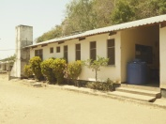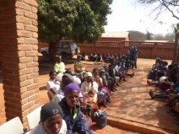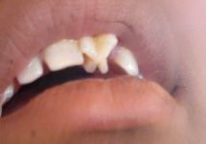
A typical clinic A typical queue A very untypical incisor
Q – Is it all work, or are there other activities?
A – While the majority of days are spent as a team treating patients, other activities which can be programmed into the visit are as much fun if not more. These include visiting local schools as a team to deliver dental advice to the kids (a favourite with most volunteers), going to a church service and experiencing African church choirs, participating in the annual Smileawi Dental Conference, ...and, of course, having a fantastic sun-blessed relaxing break in amazing surroundings at the end of your tiring but incredibly rewarding clinical stint!
-------------------------------------------------------------------------------------------------------------------------
Q – Do we meet other teams?
A – The Smileawi teams get together for a meal and drinks at the crossover days and this is a great chance for the outgoing team to tell the others of their great experience, and for the incoming team to learn more about their coming days. There is also a high chance that you will meet other teams who are providing health aid in other spheres such as doctors, opticians etc.
-------------------------------------------------------------------------------------------------------------------------
Q- What purchases and souvenirs are available?
A - Local woodcrafts and pottery are probably the best value for tourists but opportunities for shopping are limited. Prices in the few supermarkets are, maybe surprisingly, not much cheaper than the UK but sweets and treats can be bought here. Restaurant prices again are similar to the UK although drinks (when available) are a little cheaper.

Q – When should I start back to work on my return?

A – Obviously this is different for different people but you should realise that the travel time on return may be in the region of 26+ hours. Although there is no massive time zone difference, it’s likely you will be pretty tired on your return and it’s maybe advisable to give yourself a day, or at least the best part of one, before going back to work. (Of course you might be bursting to get back to tell workmates about what a great time you had!)
-------------------------------------------------------------------------------------------------------------------------
Q- Are there any books about Malawi?

A – There are several interesting books which give a flavour of the country. Particularly if you haven’t been to sub-Saharan Africa before, you might like the following:-
The Boy who Harnessed the Wind; William Kamkwamba
Rat Roads; Jacques Pauw
Into Africa: The Epic Adventures of Stanley and Livingstone; Martin Dugard
Q - Will I want to go back?
A- Yes!

